Measurement of Volume

- Given the following:
sand, 100 ml of water, a 100 ml measuring cylinder

Describe with a fully labelled diagram how you would determine the volume of the sand.
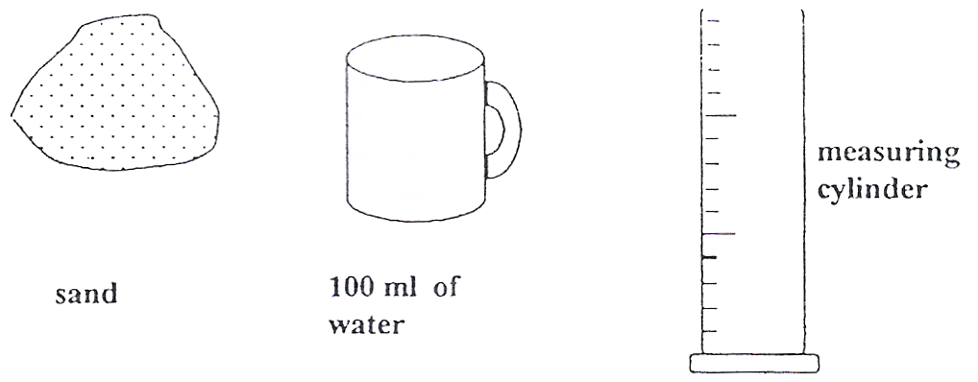

2. Given the following:
a piece of cork, stone, 100 ml measuring cylinder, thread and 100 ml of water, a displacement can.
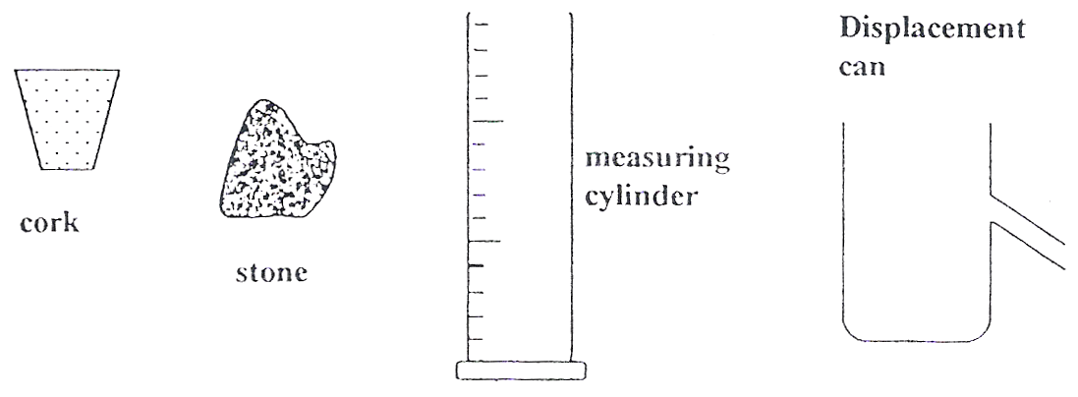
You are to draw a series of sequentially-labelled diagrams with explanations of how you would determine the volume of the piece of work.
