Advanced Placement Statistics
Practical Applications of Statistics
in the Work Place And In Everyday Life

We live in an information society; raw data, graphs, charts, rates, percentages, probabilities, averages, forecasts, and trend lines are an inescapable part of our everyday lives. It is hard to pick up a newspaper without finding an article in which a recent study makes a claim about the effect of a food product on people’s health. Studies in which people who ate oatmeal had lower cholesterol than those who did not might suggest that those with high cholesterol would be wise to eat oatmeal. In AP Statistics, we learn to examine the details of the study to see if a true experiment was conducted with subjects randomly assigned to treatments, and whether other factors were involved. Other factors include questioning whether the oatmeal really lowered cholesterol or whether the subjects ate oatmeal instead of eating four fried eggs! Would eating cornflakes have had the same effect? Is oatmeal the factor, or is it the change from a high cholesterol breakfast?


Copyright 1995 by Bill Watterson.

In the work place, statistics is used by many companies. Business decisions are made based on market research. Advertising executives want to know whether a new ad campaign significantly increases sales. Doctors must know reliability of medicine and treatments. Products such as pharmaceuticals require significant evidence of effectiveness and safety. (Examine the literature inserted in any new medicine you take to see the statistical evidence.) Politicians rely on data from polls and public opinion. Courts inquire about statistical significance in hearing class action discrimination cases. (Statistical Significance means that such results are unlikely to occur by mere chance alone.) Any company that expects to obtain a government contract must have strong evidence of a quality control program that implements Statistical Process Control. Statistical literacy is becoming very important in the work place and in society as we are all consumers of goods and services and need to make intelligent choices. Advanced Placement Statistics provides the opportunity for students to learn how to make good decisions with data.

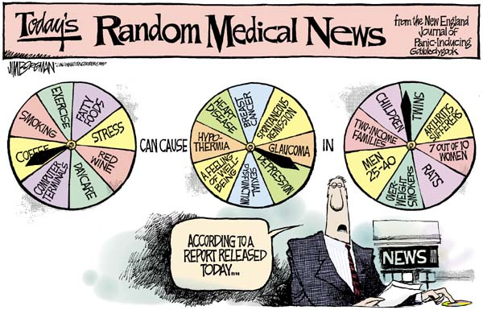

Copyright 1997 by Jim Borgman. The Cincinnati Enquirer.
Wilde Lake High School
2007-2008

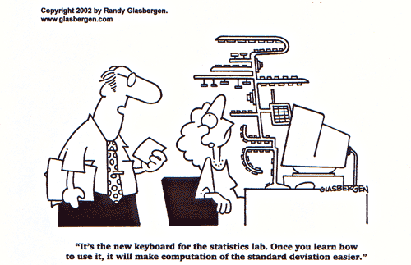
What is AP Statistics?
AP Stat is a college level introductory course in statistics. You’ll learn how to collect, organize, analyze, and interpret data. Because it’s an AP course, you can earn college credit for this course.

Why Should I Take It?
Statistics is the most widely applicable branch of mathematics. It is used by more people than any other kind of math. You’ll never wonder when you’ll ever use this stuff!

Who Uses Statistics?
Everyone who needs to collect and analyze data needs to understand statistics. That’s every branch of science, of course. And it’s also important in the social sciences (like psychology, sociology, anthropology), in business and economics, in political science and government, in law, and in medicine. There’s a very strong chance YOU will use statistics in college and in your career.

How Hard Is AP Stat?
It’s a college course, so the expectations are high. You’ll be expected to do homework every day, and not just math problems. There is reading and writing involved. In fact, if you think math is all formulas, equations, and calculations, you’ll soon find that this isn’t really a math course. It’s a course in reading, analyzing, thinking, and writing clearly.

AP STAT FAQ
Could I Take Statistics In College?
Yes, and you probably will. Statistics is required for many majors, and strongly recommended for others. Many colleges now give students a choice of Statistics or Calculus to fulfill their math requirements.

Then Why Should I Take It In High School?
There are several advantages. Here it’s a full year course so you’ll have more opportunities to ask questions and really understand the concepts than at college where the class meets only a few times per week for one semester. You will enter college ready to apply your skills in your first semester courses. Many former students have returned after a couple of years in college to say that AP Stat was the most important and helpful course they took in high school.

Would It Be My Only Math Course Next Year?
Most people take Statistics as an elective, in addition to their regular math course. You may take AP Stat and Calculus during the same year, or you may choose to just take AP Statistics.

Who Can Sign Up?
Anyone who has completed Precalculus is eligible to take AP Statistics. Your commitment to do college-level work is just as important as your math background.

What the Course Covers…
The Four Major Components of AP Stat

- Experimental Design
Students design appropriate experiments in order to draw conclusions that can be generalized to the population of interest. Students will also interpret studies and experiments to determine whether the conclusions from the studies warrant consideration.

- Exploring Data
Students collect and examine data and display the patterns that emerge. Data from students in class as well as real world data sets are gathered and used to illustrate concepts.

- Producing Models Using Probability and Simulation
Students learn to anticipate patterns and produce models for prediction. Students use simulations to model situations that are not practical to replicate using other methods.

- Statistical Inference
Students learn what can be generalized about the population. Students also consider how to investigate research questions, design a study, and interpret the results.

